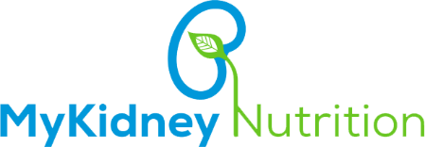

C:\Users\alpha\Desktop\Logo.png

**MyKidney Nutrition**

Installation & User Guide

Table of Contents

Introduction 3

Technology Stack 3

Installation 3

iOS 3

Android 4

Using the App 6

Introduction Wizard 6

Login Page 9

User Registration Page 9

User Profile Page 11

Completed User Profile Page 12

iOS Health App Permission Page 12

Home Page 13

Goals Page 17

Generate default Goals 17

Add/Edit Goals 17

Delete Goals 17

History & Metrix Page 20

View Record 20

Add Record 20

Food/Drug Intake Page 23

View Record 23

Add Meal/Drug Record 23

Edit/Delete Meal/Drug Record 25

Filter Meal/Drug Records via Date and Type 27

Recommendations 29

Data Sync 32

Resources 34

Logout 34

**CHAPTER 01**

Introduction, Technology stack and Installation of the VA Kidney Mobile Application (Android and iOS)

# Introduction

This document serves as a User Guide for the users of VA Kidney Mobile Application.

Patients and their caregivers experience multiple challenges managing kidney diseases. Treatment can change over time as the disease progresses, including fundamental nutritional requirements. Online nutrition tools exist but do not meet their specific needs. The VA Kidney Nutrition Mobile App addresses these needs for patients and caregivers who can use it to make smart nutrition decisions informed by their own laboratory/biometric data and personal goals.

# Technology Stack

The VA Kidney Mobile App application is built on the following technology stack

* Java (Native Android)
* Swift (XCode/ Native iOS)
* Hockeyapp (Distribution of apps)

The following tools are needed to maintain & build future versions of this app

* XCode (iOS)
* Android Studio (Android)
* Android SDK (Android)
* Hockeyapp Access

# Installation

You need to perform the following steps to install the VA Kidney mobile application.

## iOS

1. Click on Hockeyapp invite email/ sign up for Hockey app (if not already registered)
2. On your device go to Settings -> General -> Device Management -> Appirio Inc. -> Trust Appirio Inc.
3. Launch app

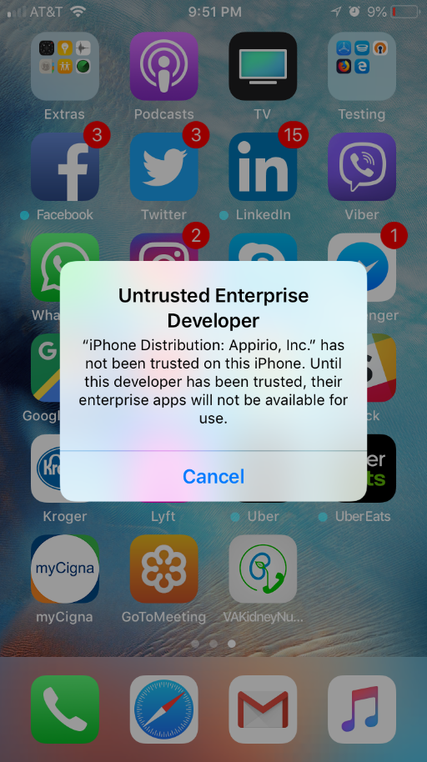 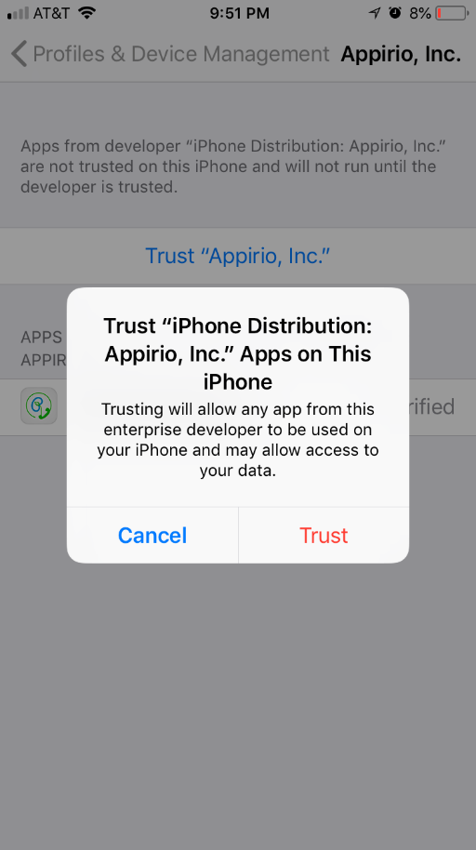 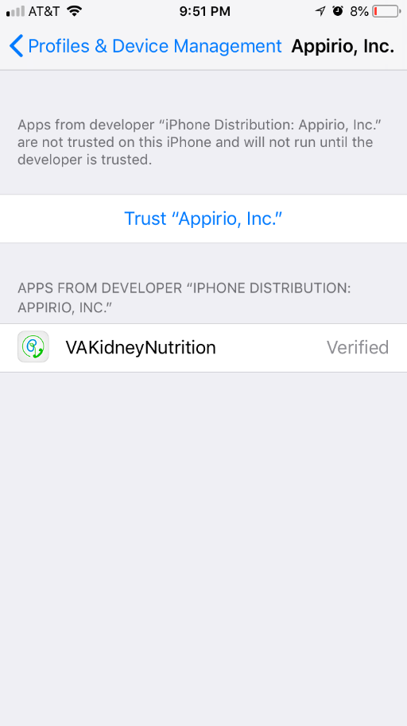

*Figure 1.3 – Device Management*

*Figure 1.1 – Developer profile*

*Figure 1.2 – Access popup*

## Android

1. Click on Hockeyapp invite email/ sign up for Hockey app (if not already registered)
2. Launch app

**CHAPTER 02**

Introduction Wizard of the VA Kidney Mobile Application (Android and iOS)

# Using the App

In the below section, the screenshots provided for iPhone. The Android flow works exactly the same.

Once you install the app, you’ll see the app launcher icon on your home screen as shown below

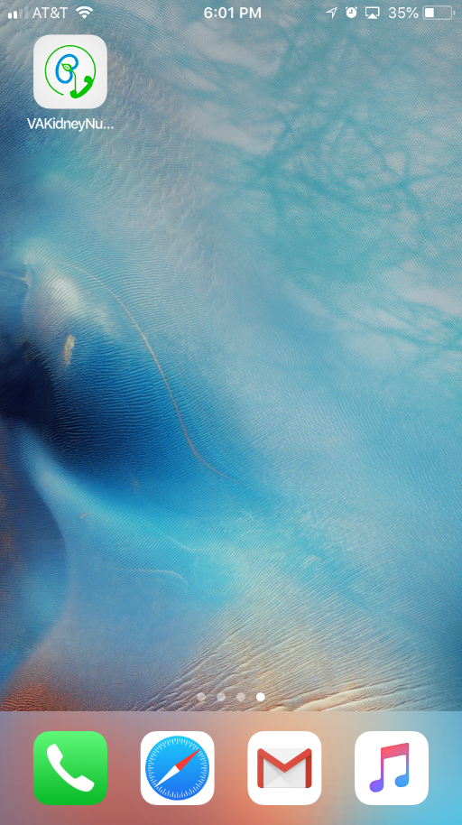

*Figure 2.1 – Application Icon*

## Introduction Wizard

1. Clicking on the app launcher icon will walk the user through an introduction wizard.
2. Clicking ‘NEXT’ takes the user to the next step in the wizard showing some more health tips ***(Figure 2.1)***
3. Clicking the arrow button on the bottom right shows more tips ***(Figure 2.2)***
4. Clicking the arrow button on the bottom right shows more tips ***(Figure 2.3)***
5. The user needs to click ‘Agree’ in order to continue using the app. Clicking ‘Disagree’ will redirect the user to help wizard again.
6. Once the user clicks ‘Agree’, they are redirected to the login screen as shown below. ***(Figure 2.4)***

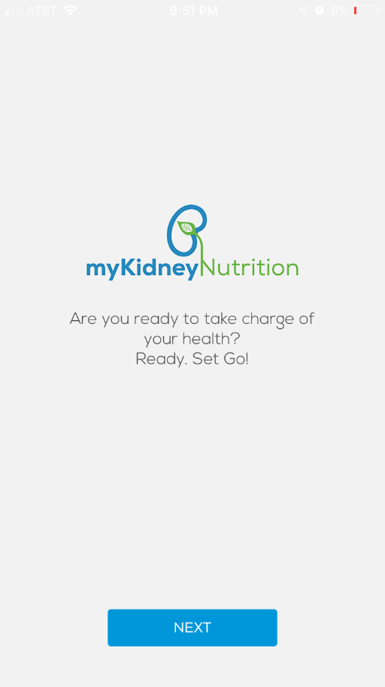 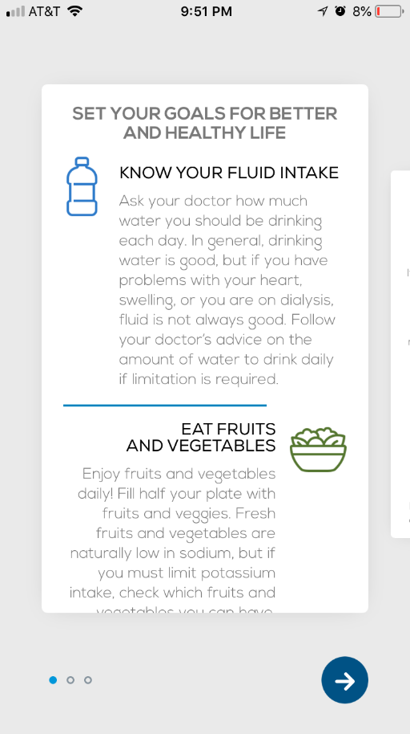 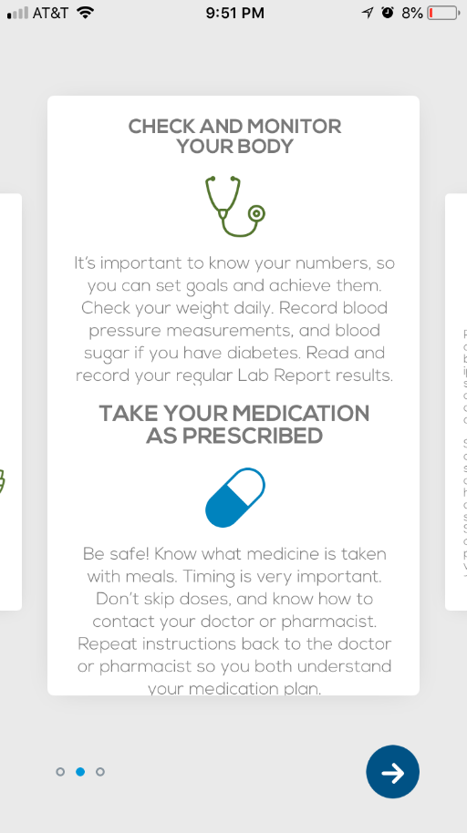

*Figure 2.3 – Slider 03*

*Figure 2.2 – Slider 02*

*Figure 2.1 – Slider 01*

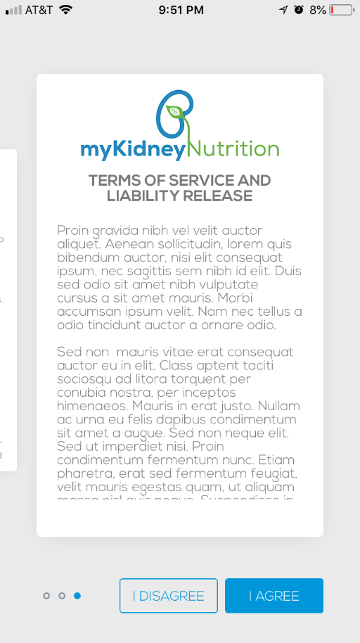 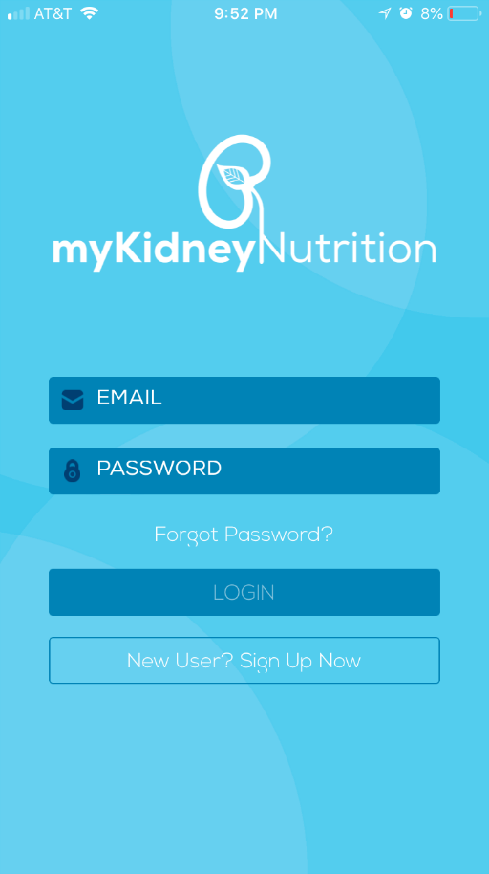

*Figure 2.5 – Login page*

*Figure 2.4 – Slider 04*

**CHAPTER 03**

Registration, Login and Profile of the VA Kidney Mobile Application (Android and iOS)

## Login Page

If user have a valid credential for the application, he/she can login to the application using it directly from the login screen. ***(Figure 3.1)***



*Figure 3.1 – Login page*

## User Registration Page

If this is the first time a user is using this application, they will need to sign up by clicking on **the ‘New User? Sign up Now’** button ***(Figure 3.2)***

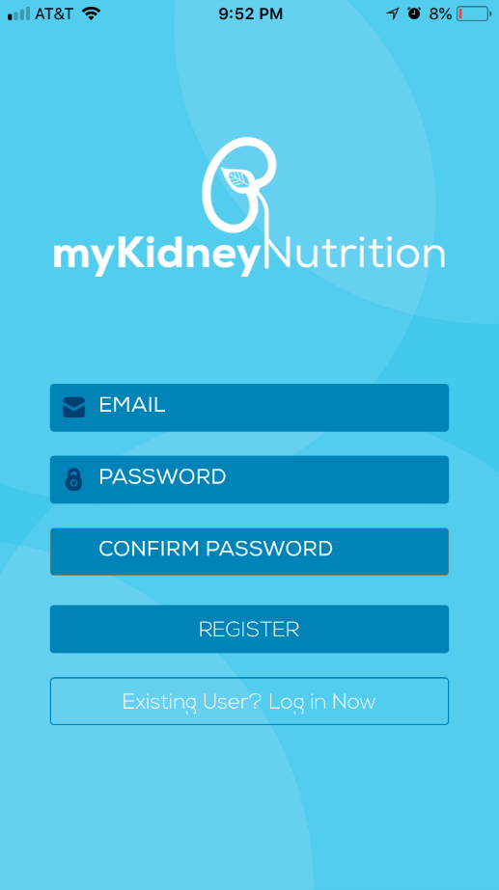

*Figure 3.2 – Registration page*

As a new user, you need to enter the following fields

* Email
* Password
* Re-enter password

Once you’ve entered, the values and hit Register, you’ll be navigated to the Profile screen as shown below. After that user can login to the system using the previously created credential to login. ***(Figure 3.1)***

## User Profile Page

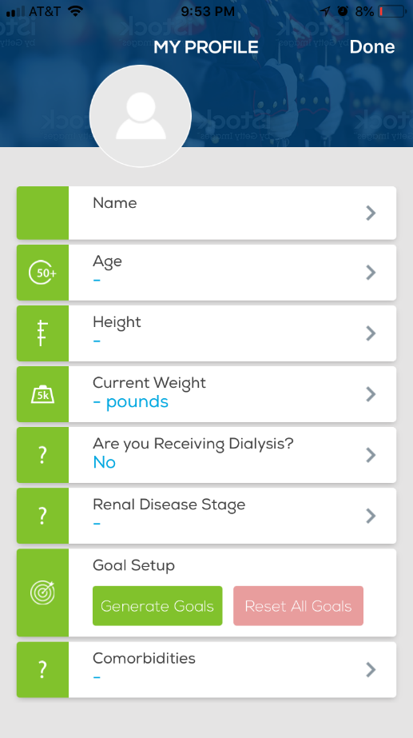

*Figure 3.3 – Empty Profile Page*

Enter your information on this screen - see example screenshot below

* **Name**: User can enter their First and Last name here
* **Age**: Younger than 16 years old can’t enter their date of birth
* **Height**: Can define from 3ft – 8ft 4in
* **Weight**: Must be define in pounds
* **Are you receiving dialysis?** Yes/No answer is required
* **Renal Disease Stage:** Can select any value from (Stage1, Stage2, Stage 3a, Stage 3b, Stage 4 and Stage 5) Get more information from <http://www.kidneyfund.org/kidney-disease/chronic-kidney-disease-ckd/stages-of-chronic-kidney-disease/>
* **Comorbidities:**

## Completed User Profile Page

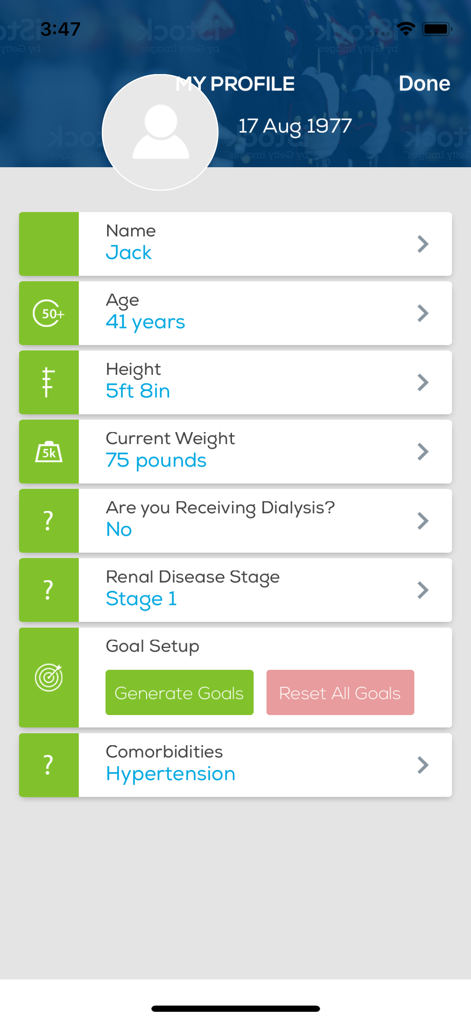

*Figure 3.4 – Filled Profile Page*

Once you have entered all the information, click ‘Done’ and it will redirect you to the permissions screen as shown below (only for iPhone, not Android)

## iOS Health App Permission Page

Click on ‘Turn All Categories on’ so that each option toggles to this view ***(Figure 3.5)***

Click ‘Allow’ and you’ll then be redirected to the screen shown below ***(Figure 3.6)***

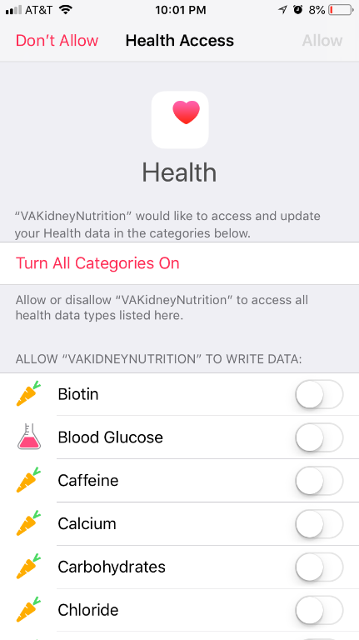 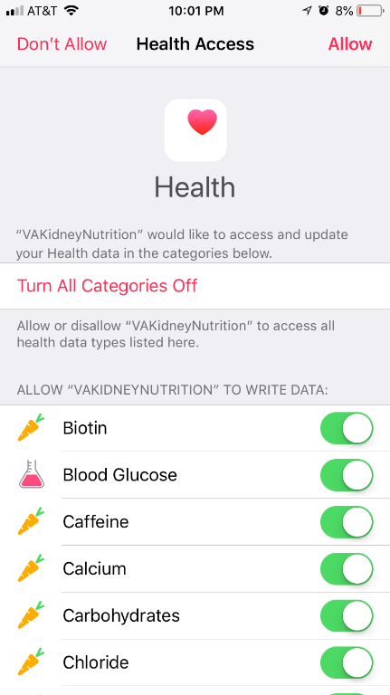

*Figure 3.5 – iOS Health App Permission*

*Figure 3.6 – iOS Health App Permission*

## Home Page

You can then use the various features of this app by clicking the respective icons shown below. ***(Figure 3.7)***

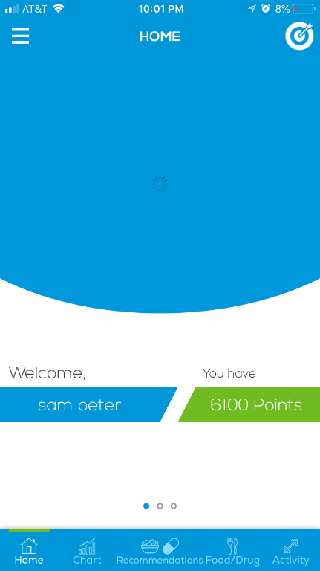

*Figure 3.7 – Home Page menu icons*

Clicking the left drawer ***(Figure 3.8)*** allows the user to access the following options (My Health Profile, Resource Library, My Biometric Device *(Not Implemented)*, Prescribed Medication *(Not Implemented)* Settings *(Not Implemented),* Reminders *(Not Implemented)* and Logout)

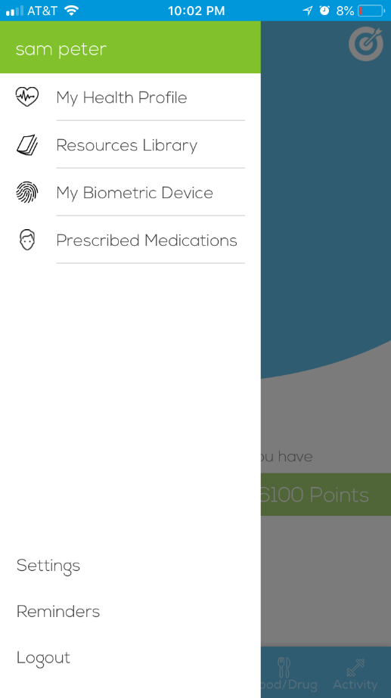

*Figure 3.8 – Menu*

On the main page there are several sliders user can access, swipe the screen left to access the others. ***(Figure 3.9) (Figure 3.10)***

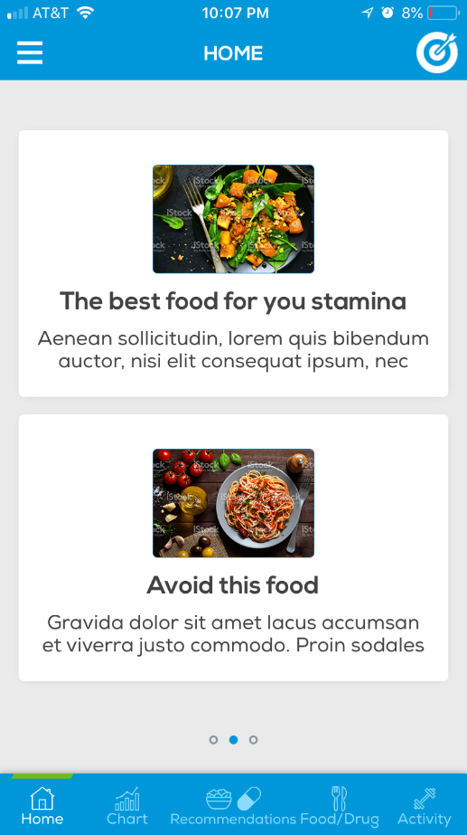 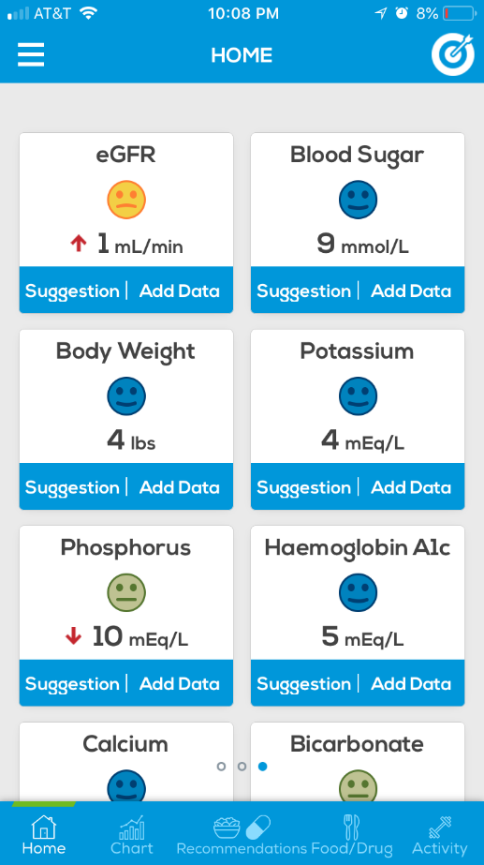

*Figure 3.9 – Home page slider 02*

*Figure 3.10 – Home page slider 02*

**CHAPTER 04**

Adding/Editing Goals to the VA Kidney Mobile Application (Android and iOS)

## Goals Page

### Generate default Goals

Clicking on the top right icon allows user to go into the goals page. If user needs to generate goals, he/she has to go to the Menu > My health Profile > Click “Generate Goals” (Green button) from the goal setup screen.

Clicking on the generate button will create default set of goals ***(Figure 4.2)***like Fluid Intake, Workout, Protein Intake, Potassium Intake, Sodium Intake, Phosphorus Intake, Meat intake and Fruit Intake etc. in iOS devices.

S

If user needs to reset the existing goal data. go to the Menu > My health Profile > Click “Reset All Goals” (Red button) from the goal setup screen.

### Add/Edit Goals

If user needs to create a new goal ***(Figure 4.1)***or edit **(*Figure 4.3)*** an existing goal he/she has to do is click on the “Add New Goal” button and enter the new values and then click on the “Save my Goal” button.

[1] If the goal is a new one it will show in the goal list with the inserted values.

[2] If the goal is an existing one, new data will replace the old data.

### Delete Goals

User can delete an existing goal by clicking on it and pressing the “Delete Goal” button **(*Figure 4.3).*** Also user can set remainders of their goals.

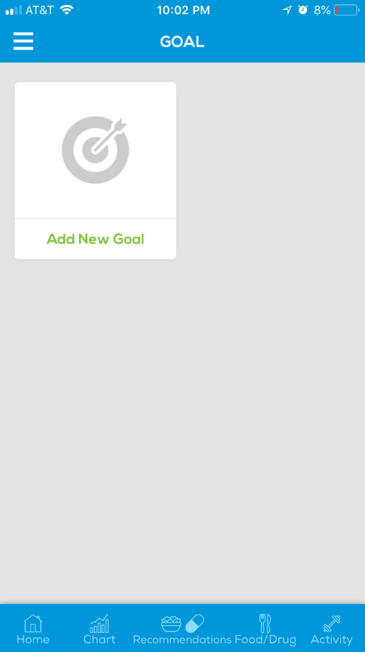 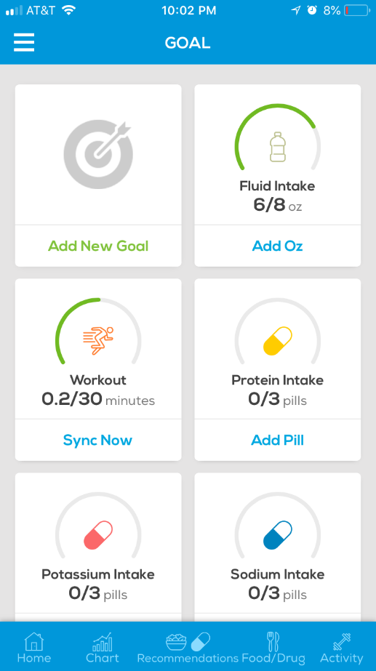 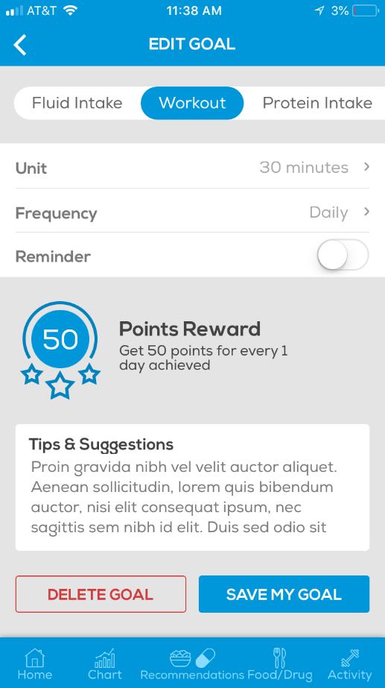

*Figure 4.3 – Delete and Edit Goal*

*Figure 4.2 – Default Generated Goal Page*

*Figure 4.1 – Empty Goal Page*

**Android** : [Add Goal](https://www.screencast.com/t/0o9uvGfsJjh) | [Edit Goal](https://www.screencast.com/t/Stxqy5PN) | [Delete Goal](https://www.screencast.com/t/54Jaaf0wQ) | [Reset and Generate Goals](https://www.screencast.com/t/3l7cLaUsbY8)

**iOS** : [Add Goal](https://www.screencast.com/t/hQmynW9xrzd) | [Edit Goal](https://www.screencast.com/t/AcfaEFx6) | [Delete Goal](https://www.screencast.com/t/eOPnOFNzMikp) | [Reset and Generate Goals](https://www.screencast.com/t/aYir9AEUHD2)

**CHAPTER 05**

History and Metrix of the VA Kidney Mobile Application (Android and iOS)

## History & Metrix Page

User can enter their daily/scheduled intakes using this page. There are several number of intakes listed by default ***(Figure 5.1)*** like Workout, Vitamin C Intake, Vitamin B1 Intake, Sodium Intake, Protein Intake, Potassium Intake, Phosphorus Intake, Meat Intake, Fruits/Veggies and Fluid Intake etc.

‘Other (Labs)’ [Android] records can be different based on the selection made by the user in the My Health Profile > Renal Disease Stage (Stage 1, Stage 2, Stage 3a, Stage 3b, Stage4 and Stage 5)

**Stage 1 and 2** - eGFR, Creatinine, BUN

**Stage 3a** - eGFR, Potassium, Creatinine, Co2 (Bicarb), BUN, 25-hydroxy Vitamin D

**Stage 3b** - eGFR, Phosphorus, Potassium, Creatinine, Co2 (Bicarb), BUN, 25-hydroxy Vitamin D, PTH, Iron Profile, Hbg or Hct

**Stage 4 and 5** - eGFR, Phosphorus, Potassium, Sodium, Creatinine, Co2 (Bicarb), BUN, 25-hydroxy Vitamin D, PTH, Iron Profile, Hbg or Hct

In iOS application above list is completely different from the Android list. (Also not changing based on the selection made in My Health Profile > Renal Disease Stage

* *Alchohol, Biotin, Blood Cholesterol, Caffeine, Calcium, Carcohydrates, Chloride, Cholesterol, Chromium, Copper, Fat Monounsaturated, Fat Polyunsaturated, Fat Saturated, Fat Total, Folate, Iodine, Iron, Magnesium, Manganese, Molybdenum, Niacin, Pantothenic Acid, Riboflavin, Selenium, Sugar, Vitamin A, Vitamin B12, Vitamin B6, Vitamin E, Vitamin E, Vitamin K, Zinc*

### View Record

User has to click on the specific records to go inside ***(Figure 5.1)***, if there are existing data it will display on a chart ***(Figure 5.4) (Figure 5.5)*** but if not there will be a blank page. ***(Figure 5.2).*** The item names with existing data is highlighted green color.

### Add Record

User have to tap on the **+ (add button)** to add records to the page and there will be a popup ***(Figure 5.3)*** with the Date, Amount and Unit. Units will be different from item to item but others are same.

After user adds the data, the chart will display the maximum and minimum values in the chart so that user can get an idea how he/she was doing. ***(Figure 5.4)***

**Android** : [Add a Record](https://www.screencast.com/t/WRPgTsVl)

**iOS** : [Add a Record](https://www.screencast.com/t/qBwl7kSa)

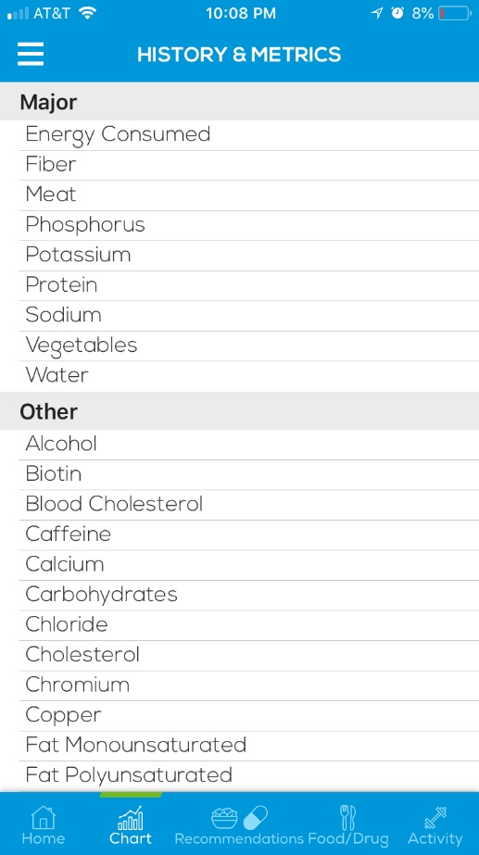 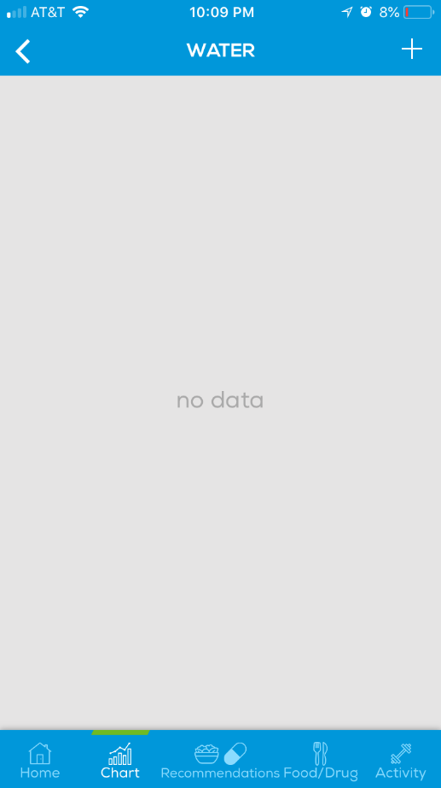 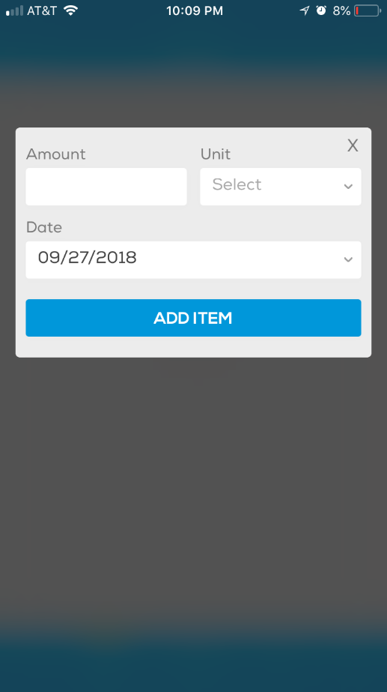

*Figure 5.3 – Add Record popup*

*Figure 5.2 – Empty Record page*

*Figure 5.1 – History & Metrix List*

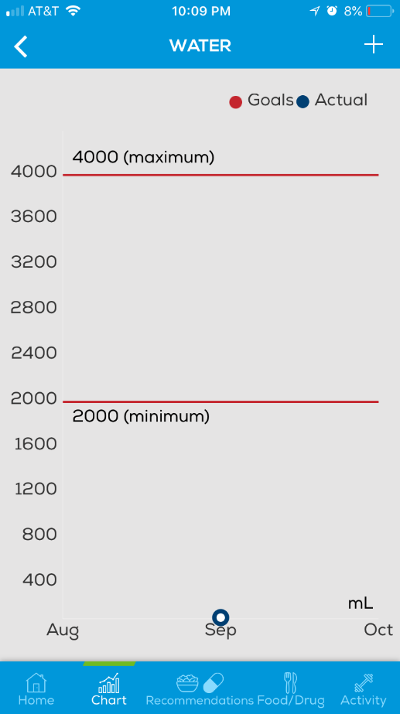 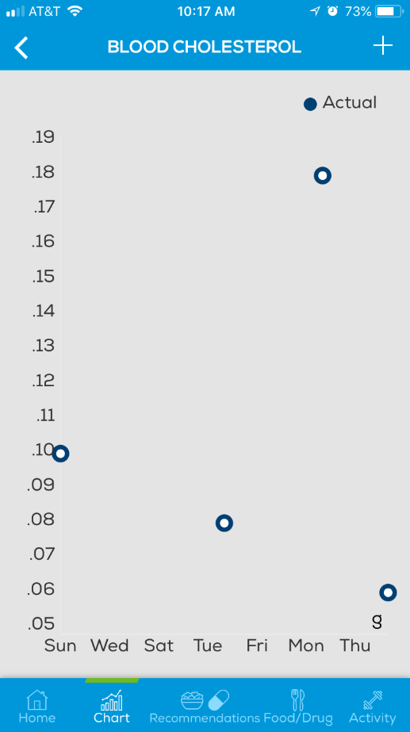

*Figure 5.4 – Existing Record page*

*Figure 5.5 – Existing Record page*

**CHAPTER 06**

Food/Drug Intake of the VA Kidney Mobile Application (Android and iOS)

## Food/Drug Intake Page

User can add a new meal/drug. There are different types of meals to select from. For example, Breakfast, Lunch, Dinner, Snack and Casual.

### View Record

To view an existing meal, user has to tap on an existing meal to see what are the details inside. ***(Figure 6.1)***

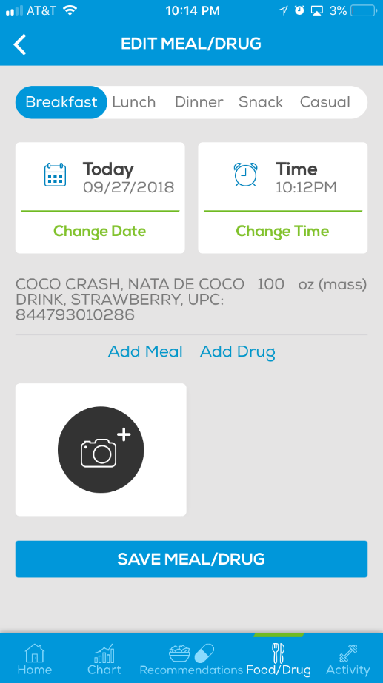

*Figure 6.1 – View/Edit meal/drug page*

### Add Meal/Drug Record

To add a meal, user needs to tap on **‘Food/Drug’** menu and then tap on the **‘Add New Meal/Drug’** button **(*Figure 6.2)*** If there are meals already user can see those on the page. After tapping on the **‘Add New Meal/Drug’** button it will ask you to input,

* Meal Type: Breakfast, Lunch, Dinner, Snack and Casual (* Required)
* Date (* Required) **(*Figure 6.5).***
* Time (* Required) **(*Figure 6.6).***
* Add the meal or meals (* Required)
* Photo(s) of the meal (* Optional)

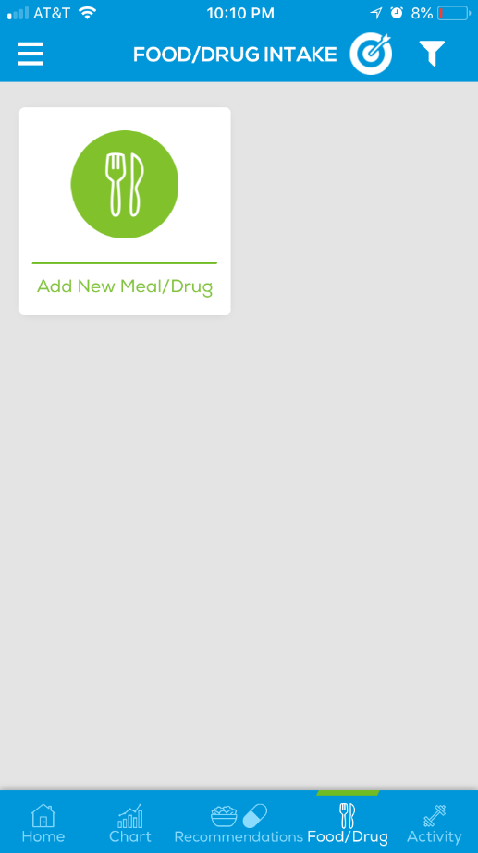 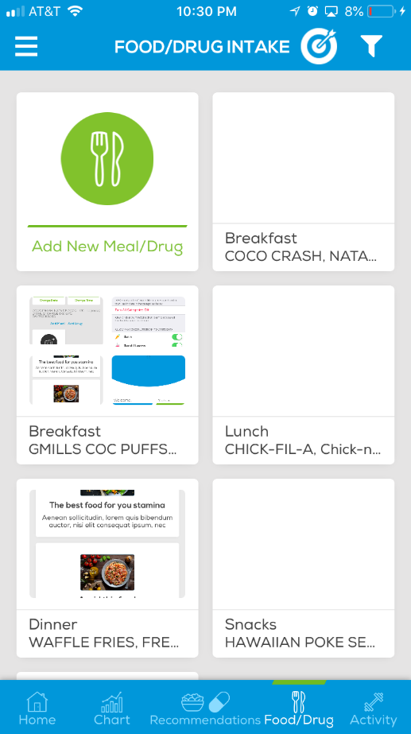 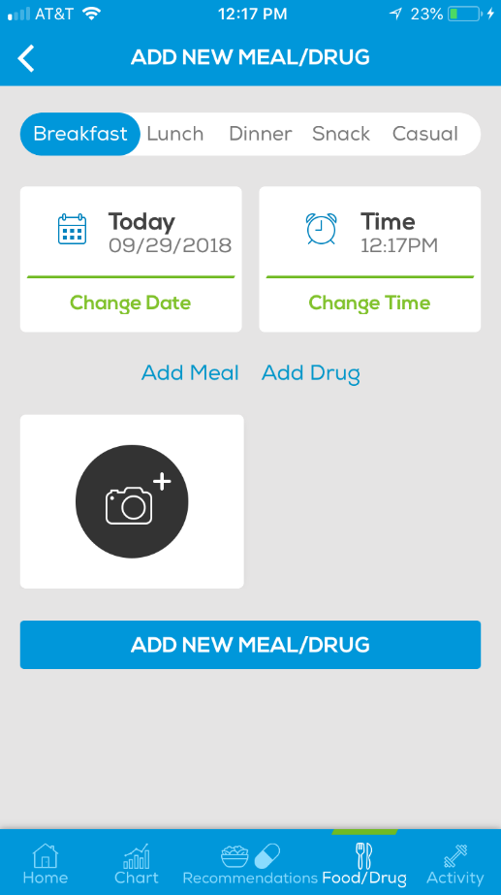

*Figure 6.2 – Empty Food/Drug page*

*Figure 6.3 – Meal/drug list page*

*Figure 6.4 – Add meal/drug page*

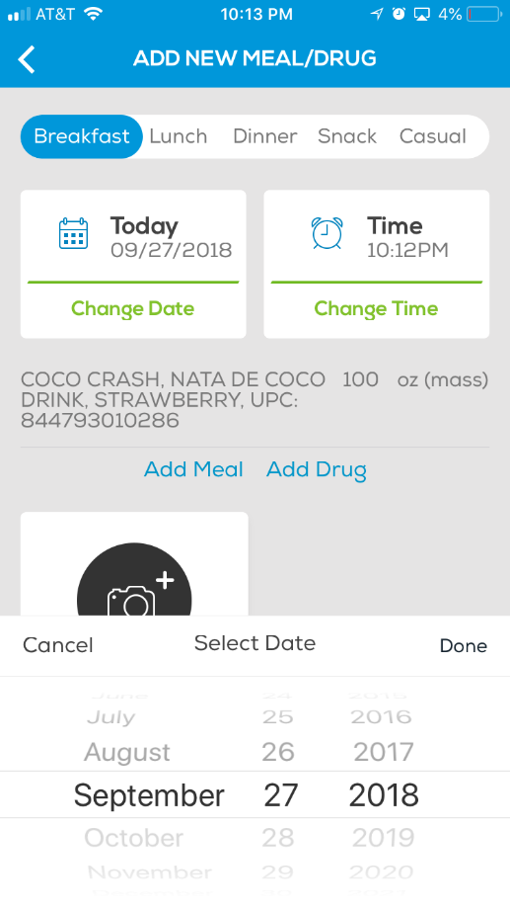 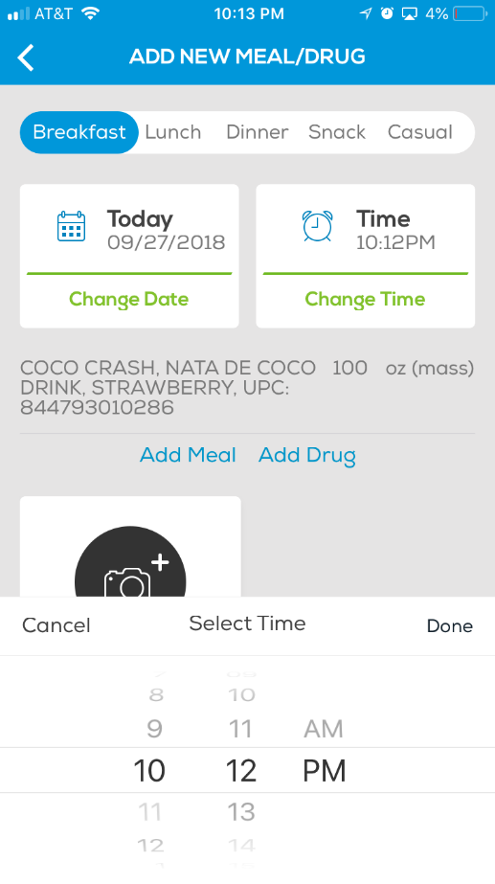

*Figure 6.5 – Change Date*

*Figure 6.6 –Change Time*

User can add any number of meals/drugs using the **‘Add Meal’** **(*Figure 6.8)*** and **‘Add Drug”** **(*Figure 6.7)*** buttons. When user enter the name of the meal/drug partially system will suggest a food/drug list so that user can easily choose from.

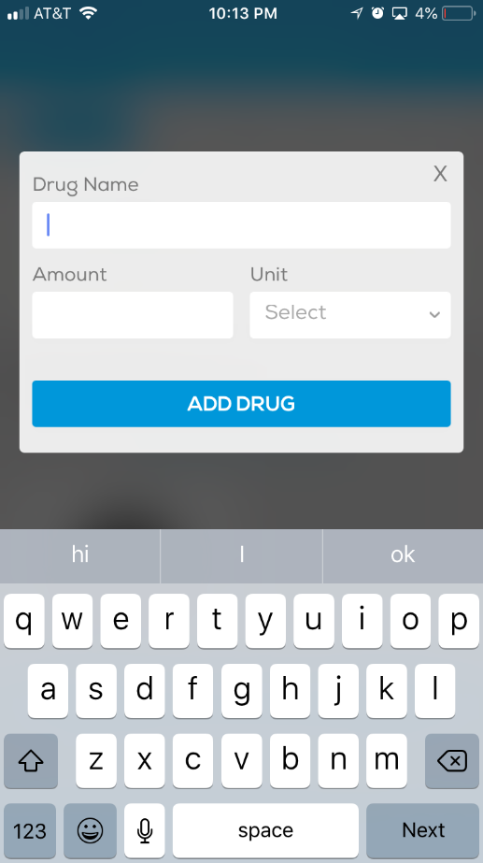 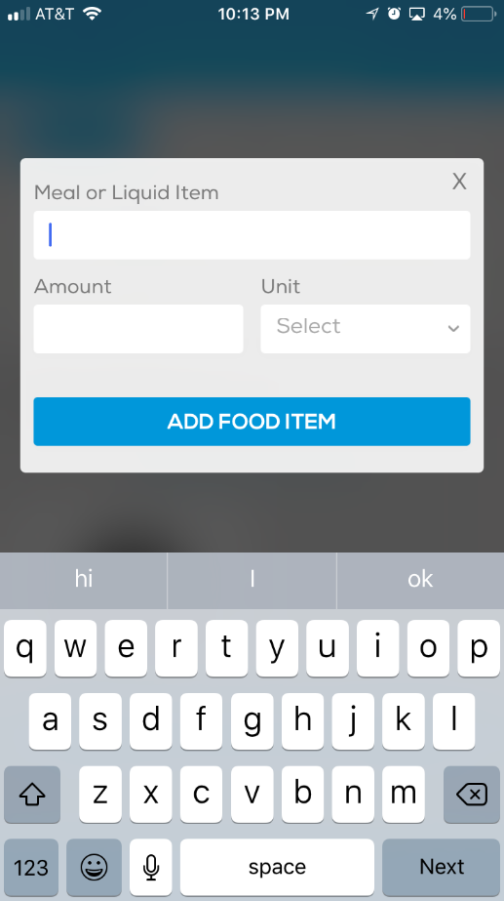 

*Figure 6.8 – Add Meal*

*Figure 6.7 – Add Drug*

*Figure 6.9 – After adding meal/drug to the list*

**Android** : [Add Breakfast](https://www.screencast.com/t/g6sYfqcdpMnd) | [Add Lunch](https://www.screencast.com/t/hhFgqg94f) | [Add Dinner](https://www.screencast.com/t/jlWWtnrb) | [Add Snack](https://www.screencast.com/t/V7m3TMLvLP) | [Add Casual](https://www.screencast.com/t/7spGT3qme)

**iOS** : [Add Breakfast](https://www.screencast.com/t/CneXM3nfXBD) | [Add Lunch](https://www.screencast.com/t/1V9kokKd) | [Add Dinner](https://www.screencast.com/t/FvF75yyE) | [Add Snack](https://www.screencast.com/t/aFJlSjkSOM) | [Add Casual](https://www.screencast.com/t/I3asOITE4DjW)

### Edit/Delete Meal/Drug Record

User can edit the already added Meal/drug by tapping on the existing record **(*Figure 6.10)***. Tapping on the existing record will display the “Edit” popup **(*Figure 6.11)* (*Figure 6.12)*** with existing data and then user can easily change it to another one and save it.

Or User can delete an existing meal/drug **(*Figure 6.11)* (*Figure 6.12)***. Tapping on an existing record and tap on ‘Delete” button will remove the existing record from the meal.

NOTE: User needs to have one meal/drug to save the existing mealtype **(*Figure 6.13)***

 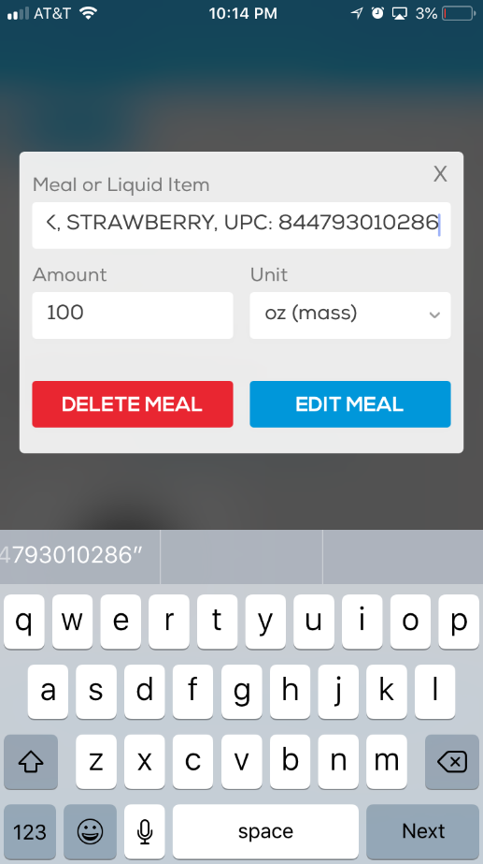 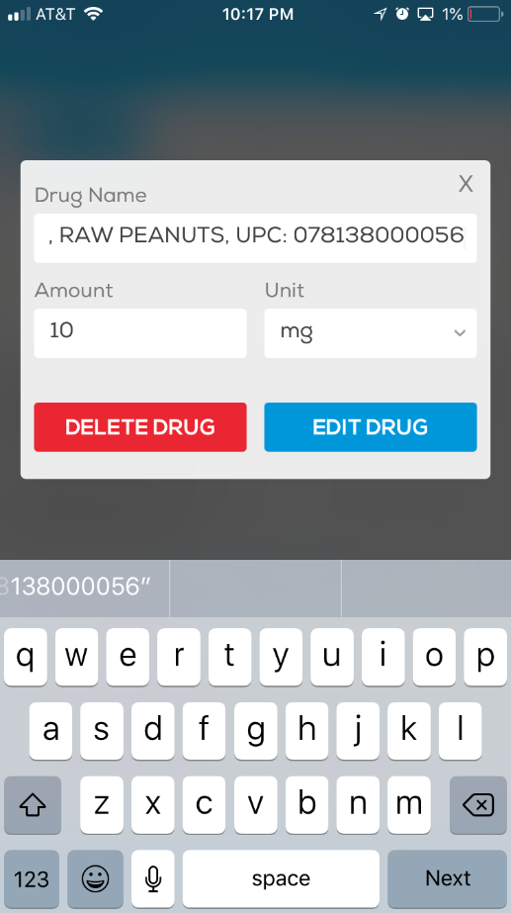

*Figure 6.10 – Existing meal/drug list*

*Figure 6.11 – Edit Meal*

*Figure 6.12 – Edit Drug*

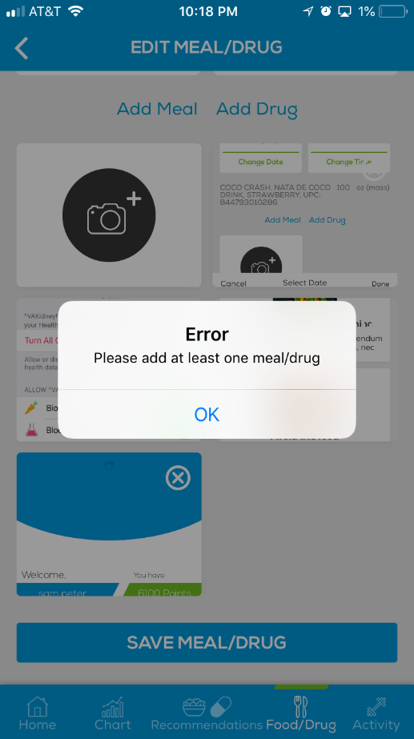

*Figure 6.13 – Error message when user tries to save without drug/meal*

### Filter Meal/Drug Records via Date and Type

By using the filter option, user can filter the items in the Meal/Drug list. There are two options to choose from [1] From Date **(*Figure 6.14)*** [2] Type {Breakfast, Lunch, Dinner, Snack, Casual} **(*Figure 6.15)***

User can use Date and Type combination both to filter out data or a single combination. Also user can filter by multiple meal types for example: Lunch + Dinner, Casual + Snack

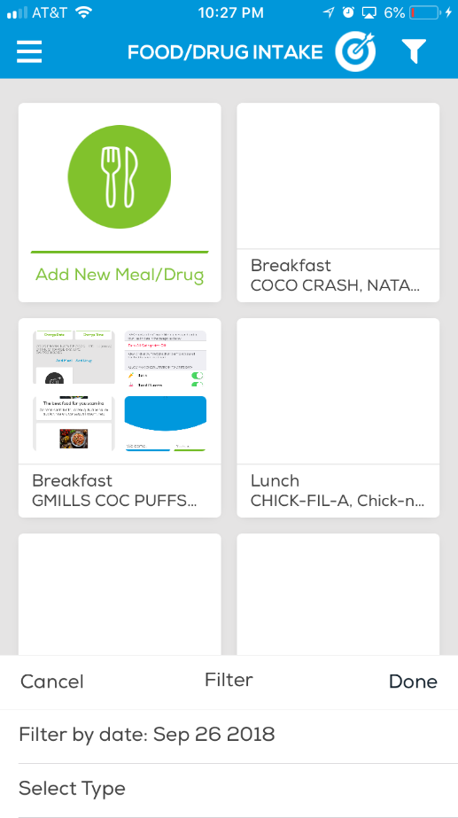 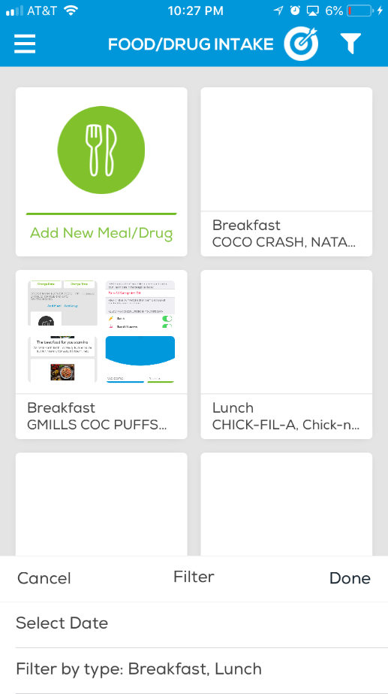

*Figure 6.14 – Filter by Date*

*Figure 6.15 –Filter by Time*

**Android** : [Filter by Date/Type](https://www.screencast.com/t/1EWD0Nsn)

**iOS** : [Filter by Date/Type](https://www.screencast.com/t/2tfEJSQH4)

**CHAPTER 07**

Nutrition and Drug Interaction Recommendations of the VA Kidney Mobile Application (Android and iOS)

## Recommendations

When user choose food and drug items for their meals, system will automatically add information about food suggestions **(*Figure 7.1)***, Unsafe foods **(*Figure 7.2)***, Medications **(*Figure 7.3)*** and drug interaction **(*Figure 7.3)*** details to the “Recommendation” menu

When user removes/ or changes the food/drug items from the “Food/Drug” menu those recommendations also will change based on the new input.

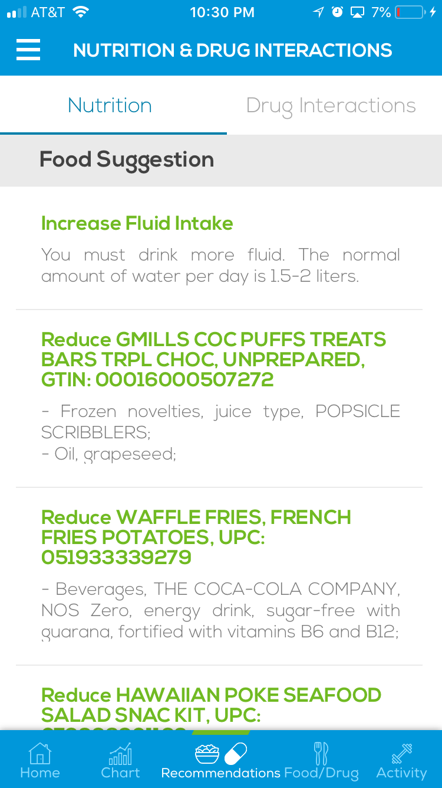 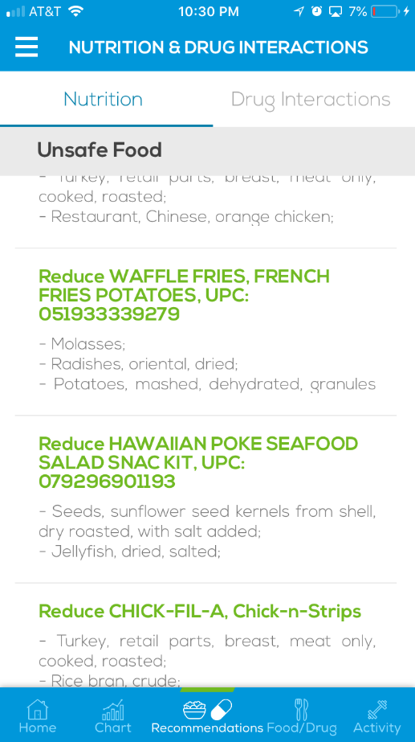 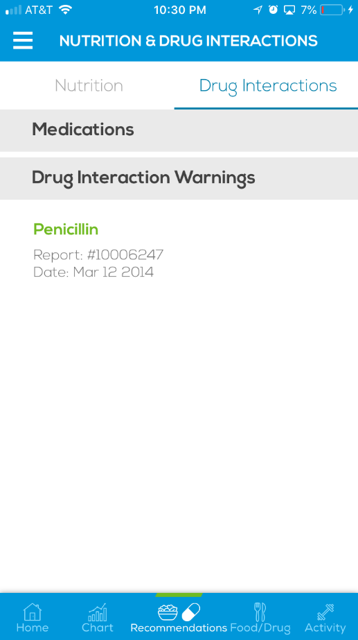

*Figure 7.3 – Drug Interactions*

*Figure 7.1 – Food Suggestions*

*Figure 7.2 – Unsafe Food*

Also user can view more details about the recommendation by tapping on an item. It will display a detailed report about the interaction. **(*Figure 7.4)* (*Figure 7.5)***

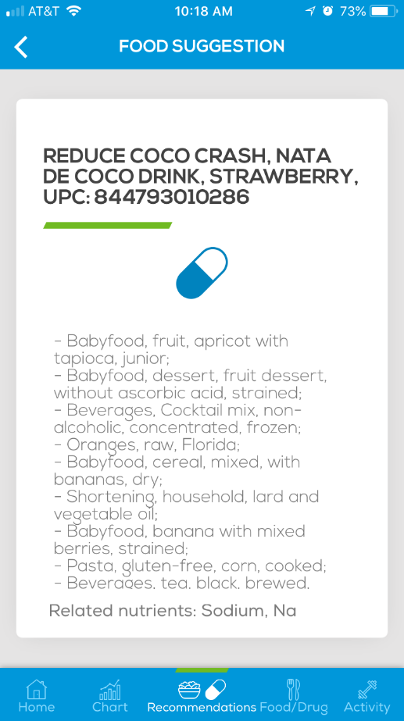 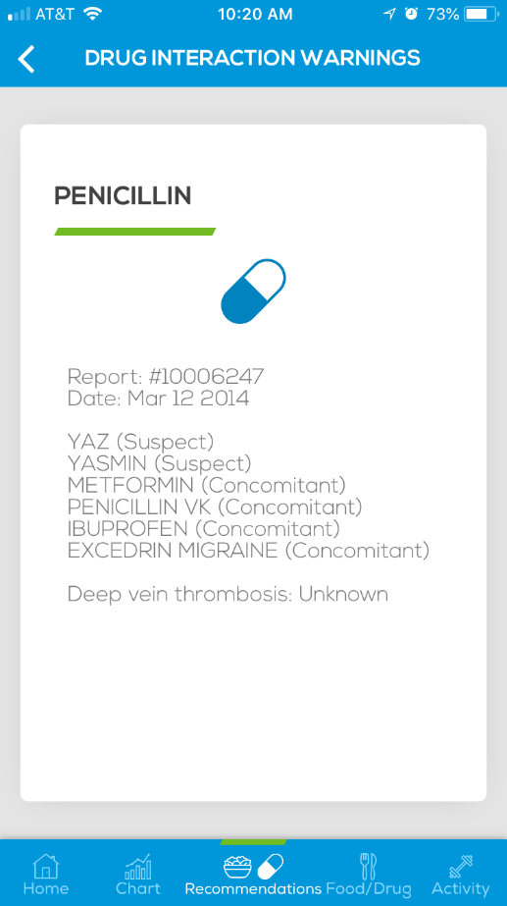

*Figure 7.5 – Detailed Drug Interaction*

*Figure 7.4 – Detailed Food Suggestions*

**Android** : [Suggestions](https://www.screencast.com/t/jqlvflhaqX)

**iOS** : [Suggestions](https://www.screencast.com/t/8INGvRcIGclF)

**CHAPTER 08**

Activity data of the VA Kidney Mobile Application (Android and iOS)

## Data Sync

User’s Distance and Steps activity data is displayed in here. The data are captured automatically from the Google Fit account (Android) and Apple Health account (iOS)

To allow the data to be synced from the Google Fit account (Android) and Apple Health account (iOS) applications, User needs to set the ‘Add Biometric Device’ to Yes (Android), then user have to give the permission to fetch the data from your account.

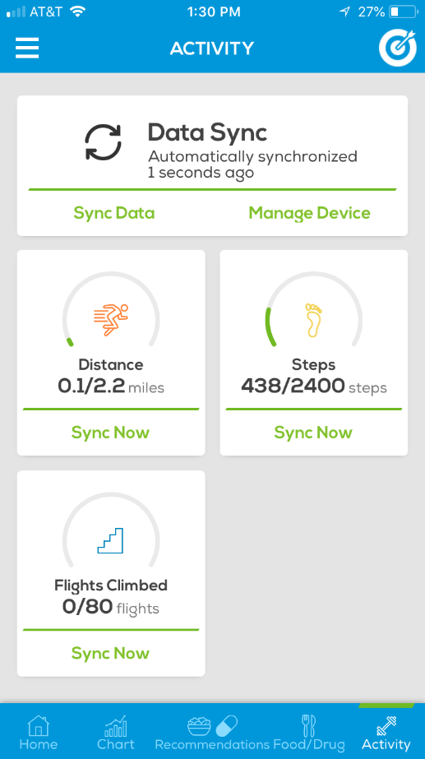

*Figure 8.1 – Data Sync*

**CHAPTER 09**

Other functions related to VA Kidney Mobile Application (Android and iOS)

## Resources

Resources page consists of varies types of information related to health. There are 3 tabs Read More, Do More and Learn More {Android} / Articles, Tutorials, Educations {iOS}.

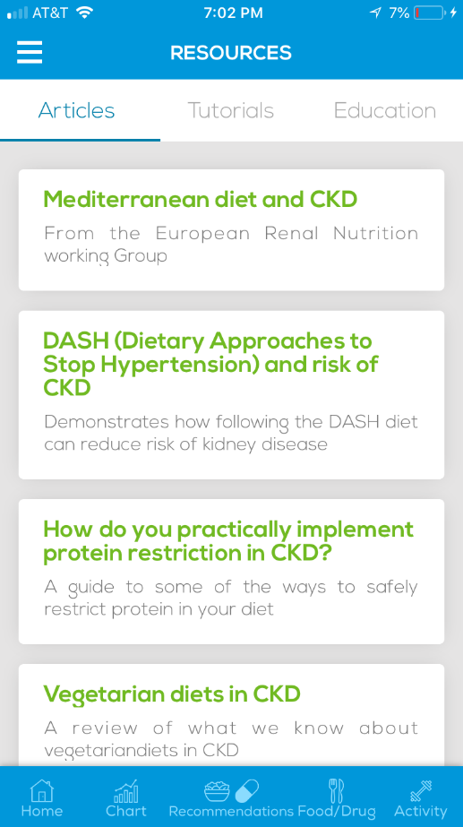 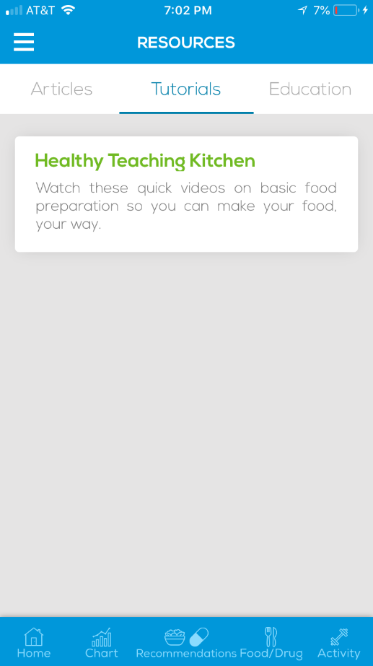 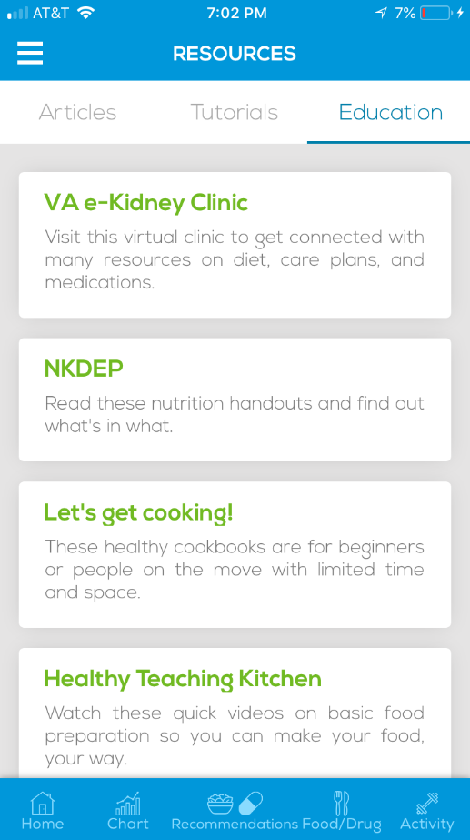

*Figure 9.1 – Articles tab*

*Figure 9.2 – Tutorials Tab*

*Figure 9.3 – Education Tab*

**Android** : [Resources](https://www.screencast.com/t/EFBCENQEJLNn)

**iOS** : [Resources](https://www.screencast.com/t/8LVz4Cgftm)

## Logout

User can logout from the system by tapping on Menu (top left corner) > Logout



*Figure 9.4 – Logout*